



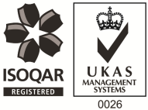
Bank Nurses – Flexible Hours - £20.00ph - £27.50ph

PAM OH Solutions is Health and Well-being provider, which provides a variety of services to clients based throughout the UK.

Currently we are looking to recruit registered nurses onto our Bank register and have openings for a variety of working hours to suit individual needs, whether you wish to work evenings, weekends or a few hours / days between Monday and Friday. The work entails undertaking vaccinations, phlebotomy, medical screening and paper reviews. Full training & ongoing support will be provided.

You'll need;
- Be a qualified RGN with a valid NMC Pin Number
- Experienced in delivering immunisations and vaccinations
We are specifically looking to recruit in the following areas:-

Hemel Hempstead Stevenage Cambridge
Chelmsford Aylesbury High Wycombe
Waterloo St Pancras Bristol & S West

