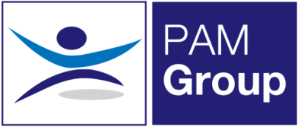


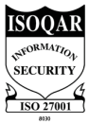
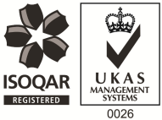
Full Time Receptionist / Customer Service Advisor

Excellent Benefits Package
We are currently looking to employ a full-time Receptionist / Customer Service Advisor to join our team at our Milton Keynes clinic.
PAM Group provides Occupational Health and Wellbeing services to a variety of customers throughout the UK including public and private sector organisations. We provide a wide range of services including Case Management, Health Surveillance, Counselling and Physiotherapy.
The role:
- Answering incoming calls in a polite and professional manner
- Greeting patients into the clinic
- Managing and maintaining the booking of appointments
- Updating information using our internal system
- Communication with clients, field based staff, colleagues and Clinics nationwide ensuring all requirements are met
- Transferring calls to the relevant departments
- Logging incoming and outgoing mail
- Monitoring an email inbox and dealing with any enquiries
- General admin duties
- Supporting clinicians where necessary
You will have:
- A professional and courteous manner with excellent customer service skills
- Excellent communication skills to communicate at all levels with Clients and Employees
- Exceptional attention to detail
- High standards and ensure all areas are kept clean and tidy at all times
Person Specification:
- You will be an excellent communicator with a smart and professional appearance.
- You will have previous front of house reception experience
- You must be comfortable with working alone
Hours:
The role is working Monday – Friday 40hrs per week. You’ll work 8hrs per day plus 30mins unpaid lunch.
The benefits package includes:
- Pension Scheme
- Health Scheme
- Life Insurance Scheme
- 33 Days Annual Leave Including Bank Holidays, pro-rata for part-time hours
If you feel this role would be suitable for you, apply now!

