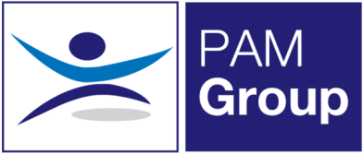


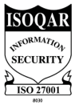
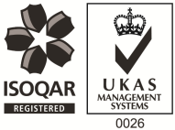
Occupational Health Nurse / Screening Nurse – Full or Part Time

Excellent Salary & Benefits Package and Training and Development Opportunities

People Asset Management is rapidly expanding, and we are now looking to employ an Occupational Health Nurse / Screening Nurse on a full or part-time basis to work with our clients. The role will include travel to our client sites in Bristol, Bath, Salisbury & Devizes. You will provide Occupational Health Services and Support to our public and private sector clients.

Working as an Occupational Health Nurse will involve:
- Immunisations & Vaccinations
- Venepuncture

Options to develop the role to involve;

- Pre-employment Health Screening
- Medical examination for screening purposes e.g blood pressure, eye tests, urine sample BMI ETC
- Drug and alcohol screening
- Audiometric screening
- Lung function screening
- Driver Medicals
- HAVS Assessments

The ideal candidate will have the following:

- You must be a Registered General Nurse
- Hold a valid NMC Pin
- Ideally have experience of working within an Occupational Health role, or have some health screening experience
- Excellent Communication skills

The benefits package includes:

- Pension Scheme
- Health Scheme
- Life Insurance Scheme
- 33 Days Annual Leave
- NMC Registration

This role would suit someone currently working as an Occupational Health Nurse, Health Screening Nurse, Practice Nurse or an Immunisations and Vaccinations nurse. Apply Now!

