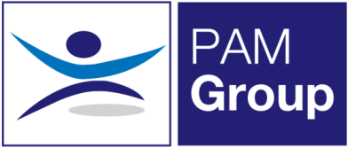


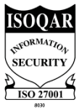
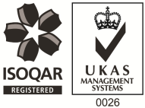
Occupational Health Nurse / Screening Nurse – Full or Part-Time

Excellent Salary & Benefits Package and Training and Development Opportunities

People Asset Management is rapidly expanding, and we are now looking to employ an Occupational Health Nurse / Screening Nurse on a full or part-time basis to work with our clients at our Folkestone clinic. This role will also involve travel to surrounding areas such as Maidstone and Canterbury, the post-holder must be flexible to travel. You will provide Occupational Health Services and Support to our public and private sector clients.

Working as an Occupational Health Nurse will involve:
- Immunisations & Vaccinations
- Venepuncture
- Pre-employment Health Screening
- Medical examination for screening purposes e.g blood pressure, eye tests, urine sample BMI ETC
- Drug and alcohol screening
- Audiometric screening
- Lung function screening
- Driver Medicals
- HAVS Assessments

The ideal candidate will have the following:

- You must be a Registered General Nurse
- Hold a valid NMC Pin
- Ideally have experience of working within an Occupational Health role, or have some health screening experience
- Excellent Communication skills

The benefits package includes:

- Pension Scheme
- Health Scheme
- Life Insurance Scheme
- 33 Days Annual Leave pro-rata for part-time work
- NMC Registration

This role would suit someone currently working as an Occupational Health Nurse, Health Screening Nurse, Practice Nurse or an Immunisations and Vaccinations nurse looking for part-time work. Apply Now!

