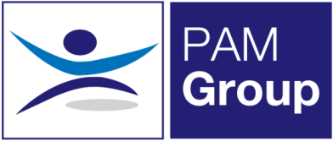



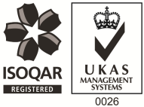
Occupational Health Physiotherapist – Full or Part Time

PAM Group is a highly experienced Occupational Health and Wellbeing specialist, providing services to more than 450,000 employees across the UK in both the public and private sector. We have over 10 years’ experience, working with clients to reduce absence and promote health and wellbeing in the workplace. We provide a wide range of services including Physiotherapy and Rehabilitation Services, Case Management, Psychological Return to Work Services, Wellbeing Services FCE’s as well as Job Task Analysis.
Due to significant business growth, we are currently looking to employ a Physiotherapist to join our team. The role is a mixture between home-based work and providing services 2 days per week to client sites in Dartford, Greenhithe & Erith.
As a growing organisation this is an exciting time within the business with excellent opportunities for those joining us.
The role will involve:
- Delivering a thorough and detailed assessment, using appropriate clinical techniques and equipment.
- Recording the information in line with clients SLA’s and CSP guidelines.
- Delivering evidence-based intervention / treatment to all patients, in line with CSP, and NICE guidelines, and in accordance with the PAM Wellbeing Treatment pathway.
- Providing appropriate advice based on the patient’s medical, social and cultural circumstances.
- Formulating and delivering individual physiotherapy treatment programmes and group exercise/education programmes using clinical assessment and reasoning skills.
- Formulating treatment plans / goals, assisting and enabling patients to achieve their treatment goals and targets.
- Maintaining accurate, comprehensive, contemporaneous patient records in line with CSP standards of practice.
- Providing hands on physiotherapy interventions and assessment.

The post holder will ideally have the following:
- CSP Registered
- HPC Registered
- Have previous experience in an OH setting desirable but not essential as training provided
- Effective Communication skills

The Company fully believes in supporting its staff members and has supported a number of employees through further development courses. PAM Wellbeing also offers an excellent benefits package including:
- Pension Scheme
- Health Scheme
- Life Insurance Scheme
- 33 Days Leave Including Bank Holidays (pro rata for part time)
- Career progression
- Support with CPD and registration fees

Please note: There is no set closing date for this role. We work through applications as and when they come through.
If you feel you would be suitable for this role, apply now!

