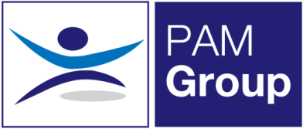


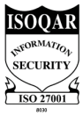
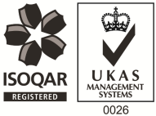
Occupational Health Advisor – Full or Part-Time

Competitive Salary + Car Allowance - Competitive Benefits Package
PAM OH Solutions is looking to employ an experienced Occupational Health Advisor to provide services at our clinic in Milton Keynes. This role also involves travelling to our client’s premises in areas such as Stevenage, Aylesbury, Hatfield and High Wycombe. The post holder must be flexible to travel.
The post will be working on a part-time basis and you will provide Occupational Health services and support at our clients sites. The successful candidate will be responsible for the full remit of Occupational Health, including pro-active Sickness Absence Management of short and long term absence cases and Health Surveillance.
The role will involve:
- Advising on phased return to work programmes.
- Conducting Health Assessments, reporting on the outcomes within agreed timescales and to PAM OH standards, policies and procedures and NMC guidelines.
- Managing Health Records ensuring safe storage, security and confidentiality of all OH records, at all times complying with relevant legislation and good practice.
- Produces management reports as required.
- Actively promotes fitness for work, both preventative and rehabilitative, raising the profile of OH amongst all levels of employees and management.
- Supports the Businesses in reducing absence and improving their people potential at all times.
- Provides clear pragmatic advice to clients and employees that adds value to their decision making
- Seeks continuous improvement in the service provided, identifying opportunities to develop the function and proposing improvements and suggestions for continuous improvement.
- Undertaking health surveillance including Audiometry, Spirometry and Vision Testing

The ideal candidate will have the following:

- You must be a Registered General Nurse
- Hold a valid NMC Pin
- Hold or be working towards an Occupational Health Qualification, either certificate, degree or diploma
- Have experience of working with an Occupational Health role
- Effective Report Writing Skills
- Excellent Communication skills

The benefits package includes:

- Pension Scheme
- Health Scheme
- Life Insurance Scheme
- 33 Days Leave Including Bank Holidays, pro-rata for part-time work
- Car Allowance & Mileage
- NMC Registration

If you feel this vacancy would be suitable for you – apply now!

