Account Manager | 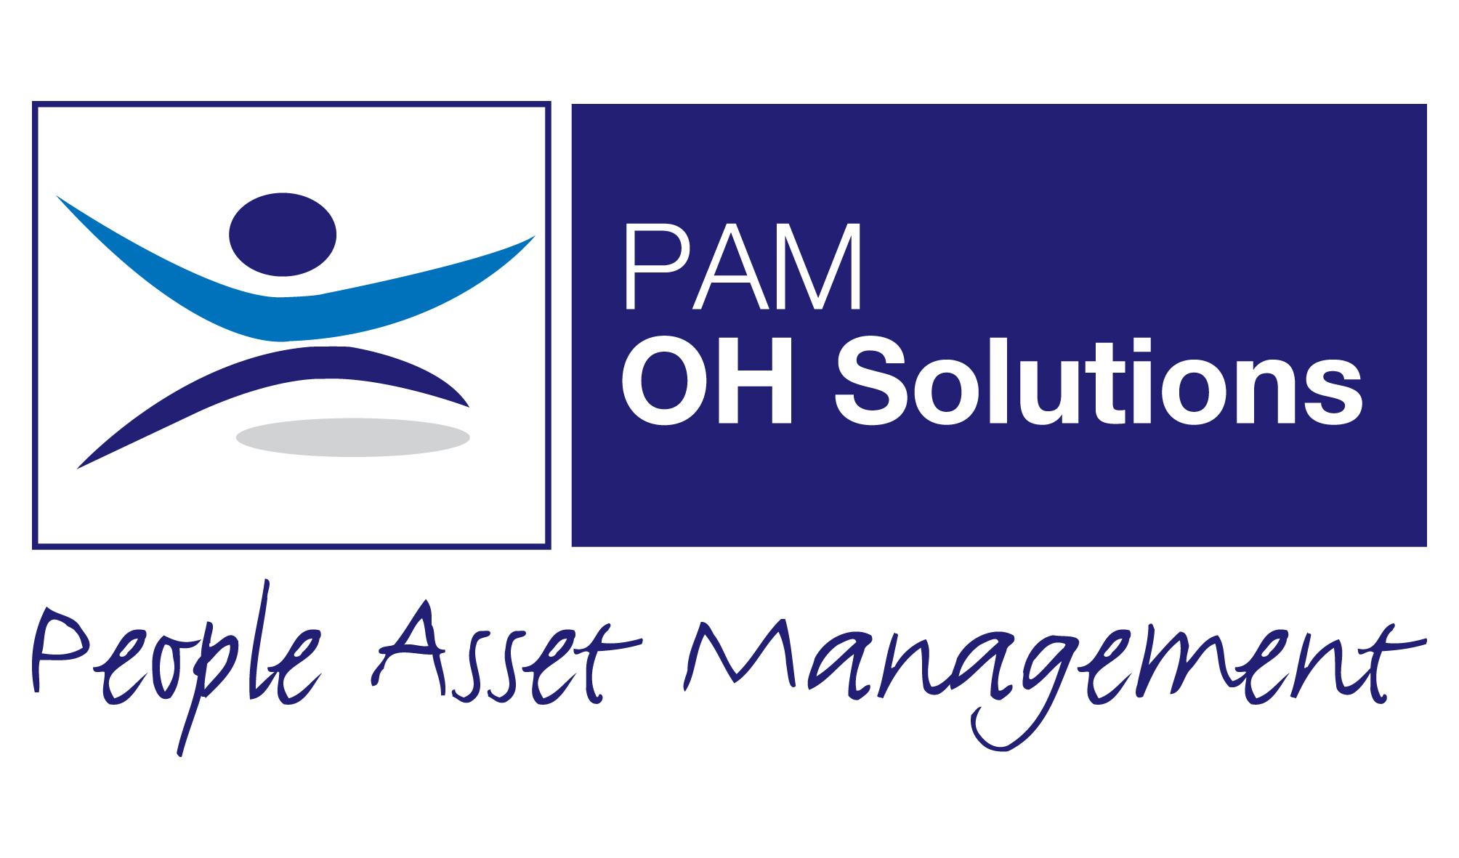

About Us

PAM OH Solutions provides occupational health and HR services to a range of multi-national clients in the private sector and public sector organisations. The business is privately owned by its directors who have a wealth of experience in providing occupational health services, employment law and business management. Since the launch the business has built a strong portfolio of clients throughout the UK and has a comprehensive range of qualified staff based regionally in order to maintain its growth.

The Directors bring both a medical background and a business management background to the business. This allows empathy and understanding of both the challenges and the requirements of our clients. The strengths of this joined up approach are therefore in the service, which is clear, pragmatic, and wholly aligned to the client's requirements.

We have always sought to provide the highest quality clinical and customer service. We have achieved ISO 9001, ISO27001, SEQOHS and Investors in People Accreditations which underlies our commitment to providing a high quality occupational health service and supporting our employees.

We are committed to putting our staff first and believe that a satisfied and motivated team reflects well on our client base.

Our Mission

We have a set of values, which are central to how we operate all colleagues must be completely comfortable with these

Everyday things that matter …………………..

- Giving clients the reason to choose us to provide their services
- Providing the highest levels of service to every client everyday
- To always give clients value for money
- To be the best we can be everyday

Our mission is simple we do not want to be the biggest but we do want:

‘To be the best provider of specialist occupational health advice in the UK and to exceed our clients’ expectations’.

- We believe that people are the most important asset in a business
- We operate to the highest possible standards at all times
- We are committed to developing long term relationships
- We will constantly innovate and improve our service
- We will listen to our clients and respond to their needs
- We will build trust with each other and our clients by being open and honest
- We will not grow at the expense of quality
- We will always seek to work with and for our clients first

People Asset Management Ltd is an Equal Opportunity employer and as such aims to eliminate any discrimination in employment practices on the grounds of gender, sexual orientation, gender reassignment, domestic circumstances, race, colour, nationality, religious belief, age, disability, marital status, political affiliations or Trade Union membership.

For further details please contact us on 01925 227000

Job Details
Job Title | Account Manager
Location | Home based with Travel
Reporting to | Head of National Client Account Relationships

Main Purpose of Job
PAM Group is rapidly expanding, and as the largest business within the Group, PAM OH Solutions is a national occupational health provider that proactively helps employers to reduce sickness absences and boost employee wellbeing. We work with clients across all industry sectors, delivering a flexible range of high-quality, proactive, and cost-effective solutions.

When you work for PAM, you’ll work with some of the most experienced Occupational Health clinicians in the UK and have the opportunity to work with organisations who want to make a positive difference in employee wellbeing.

We are looking for an experienced and dynamic Account Manager, with a strong track record of high performance, to join our National Client Relationship Team. You will be responsible for developing and nurturing relationships with a portfolio of existing Occupational Health clients, preventing account issues with a proactive approach, and establishing relationships at the Director level. You are expected to cross-sell additional products and services and lead contract renewals. This role requires an Account Manager to successfully cultivate consistent growth acting as a strategic advisor to your clients.

Hours of Work
Monday – Friday 40 hours per week, (local start and finishing times are flexible and can be determined).

Accountabilities
- Responsible for a portfolio of Occupational Health clients
- Provide proactive and consultative client support, ensuring high retention and net revenue growth within your portfolio of clients. This is executed by a deep understanding of each client’s business models, the contracts, and their needs and by providing solutions that will add value to their business
- Manage client interactions with a focus on growth opportunities
- Occasional travel to client sites
- Provide clients with detailed proposals and product demonstrations
- Build strong current knowledge of competitor intelligence
- Provide actionable customer feedback to key stakeholders to continually improve the service
- Collaborate with colleagues from other PAM businesses to benefit clients and meet their wider business objectives
- Use the PAM Way of Account Management, have an active Account Plan with renewal strategy – and lead the renewal process

- Account management building close and effective working relationships.
- Ensuring service levels are maintained through collaborative working with operational team
- Excellent administration and problem solving
- Managing systems and reporting on service levels
- Using data analytics to identify trends and areas for potential growth of service uptake.
- Ensure effective internal communications.
- Work closely with colleagues and manage projects delivering successful outcomes.
- Maintaining confidentiality at all times
- Monitoring OHIO compliance to ensure that all information is correct and completed.
- Maintaining high levels of customer service
- Developing and maintaining effective relationships with Clinical and Client Service Operational Teams providing support to them, where necessary.
- Providing support to new team members.
- Keep working practices in line with company accreditations including ISO 9001, 27001, SEQHOS and IIP

Dimensions
The post holder work will work with a Portfolio of clients in a peripatetic role Nationwide.

You will be expected to contribute to the business success and work closely with clients and clinicians to ensure delivery of Safe, Effective and Quality service.

Travelling as part of the role is necessary however PAM will always look to minimise this.

You will use our systems and must have good IT skills using the internet and Microsoft Office software.

Complexity and Creativity
The post holder will demonstrate the ability to create solutions to issues and support the PAM culture of providing clear and pragmatic advice.

Using the escalation and support mechanisms as and when required Contributing to the sharing of best practice in managing Occupational Health and Wellbeing.

The ideal candidate will have previous experience in delivering services to clients within a similar sector. They will also be able to demonstrate excellent communication skills with proven customer service experience within a business to business sector. Will have a resourceful, strong motivational ability and a commitment to service delivery excellence.

Skills Knowledge & Experience/Person Specification
- Ideally previous experience (1/2 years) in an Account Management and Relationship role
- You will be educated to degree standard or equivalent
- Excellent commercial experience
- Experience of dealing with clients and colleagues at all levels
- Ability to work to targets
- The ability to manage in a fast moving environment dealing at all levels in the organisation
- Excellent communication skills and IT proficiency
- The ability to manage a growing client and deliver opportunities
- The ability to retain a strong relationship with client
- Be self-confident, smartly presented and well organises their daily workings

Contacts
Internal Colleagues

- Client Service Teams across the Group
- Clinical Teams
- Head of National Client Relationships
- Business Development
- IT
- Finance

External
- Client Managers
- Employee’s
- GP and other health professionals

